**Phase 4: Process Automation (Admin)**

**Goal:** The goal of this phase is to automate repetitive administrative tasks in the **Student Management System**. Using Salesforce automation tools, we ensure student records are accurate, status updates are automatic, reminders are sent on time, and approval requests are streamlined without manual effort.

**1. Validation Rules**

**Object:** Student__c

* **Rule:** Ensure Enrollment Year is not in the future.
* **Condition:** Enrollment_Year__c > YEAR(TODAY())
* **Error Message:** "Enrollment Year cannot be greater than the current year."

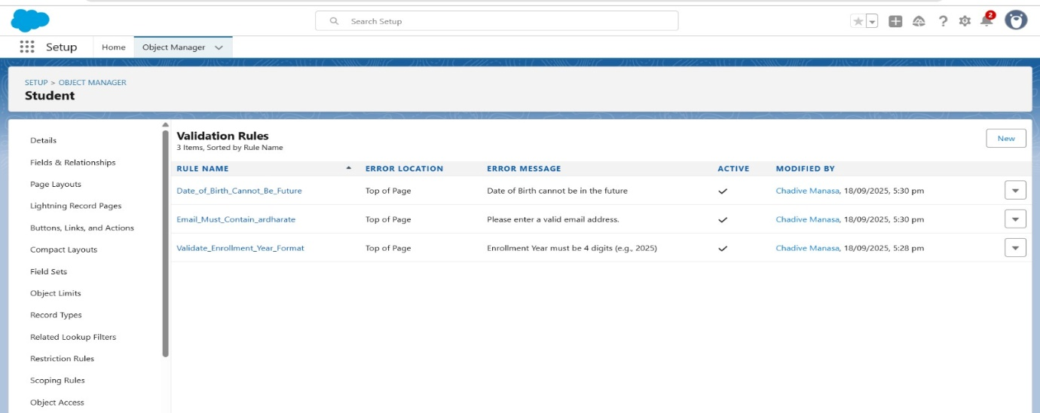

**2. Workflow Rules**

**Object:** Student__c

* **Rule Name:** Inactive Student Update
* **Criteria:** Enrollment_Year__c < TEXT(YEAR(TODAY()))
* **Action:** Field Update → Status__c = "Inactive"

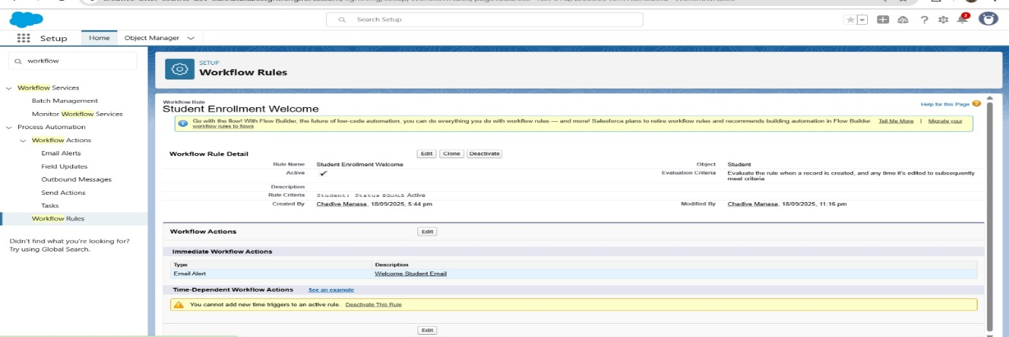

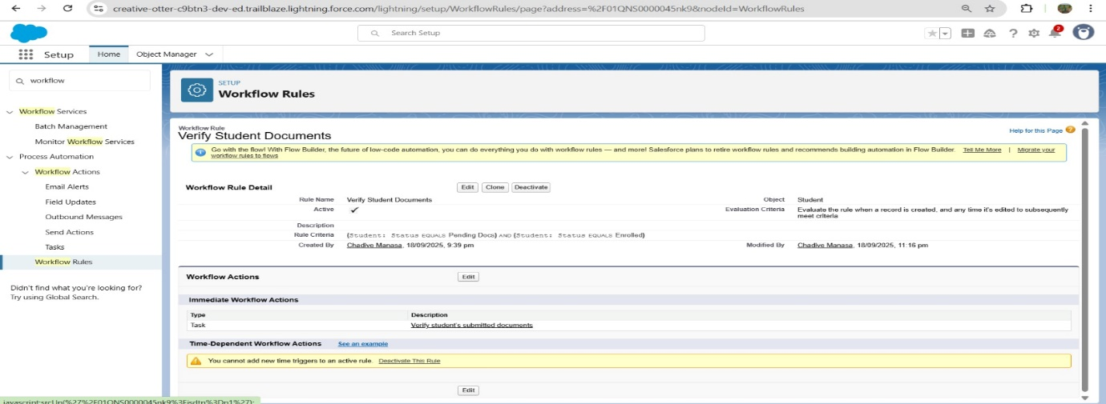

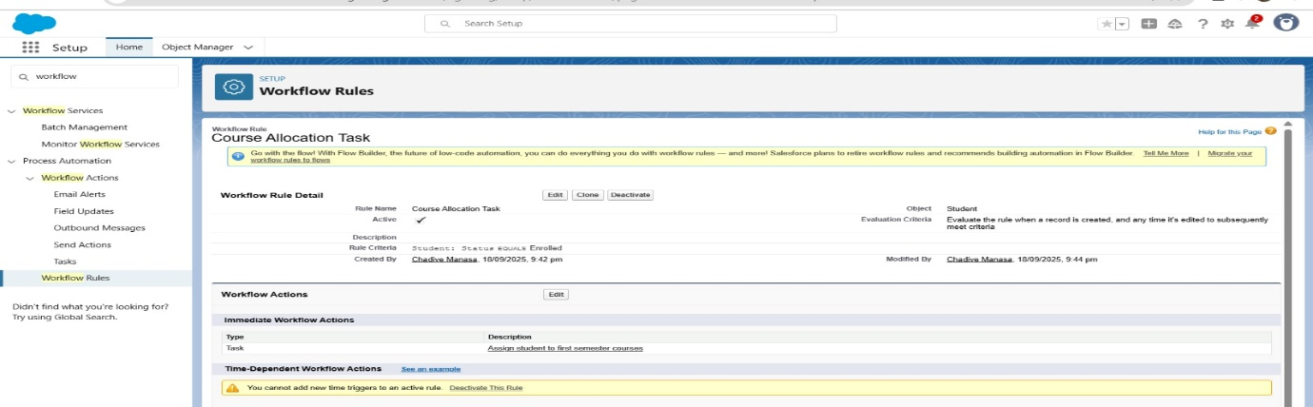

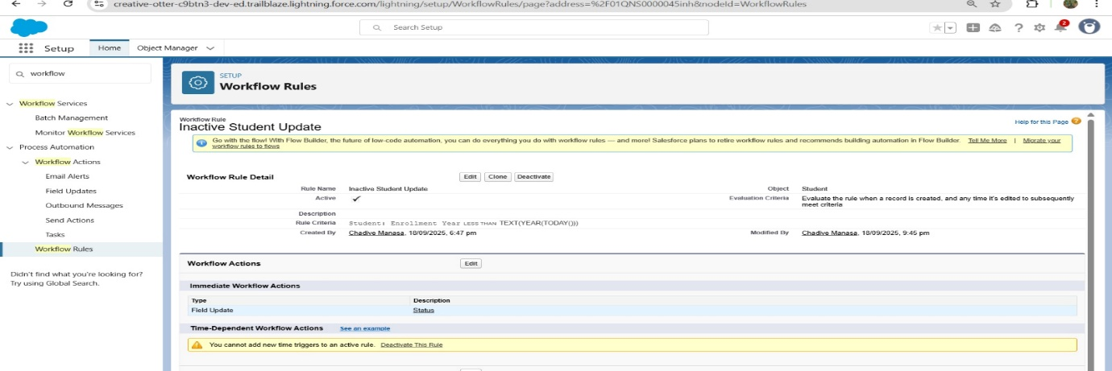

**3. Process Builder**

**Object:** Student__c

* **Process Name:** Graduation Update
* **Criteria:** When Status__c = "Graduated"
* **Action 1:** Update Field → Graduation_Date__c = TODAY()
* **Action 2:** Send Email Alert → “Graduation Congratulations Email” to student.

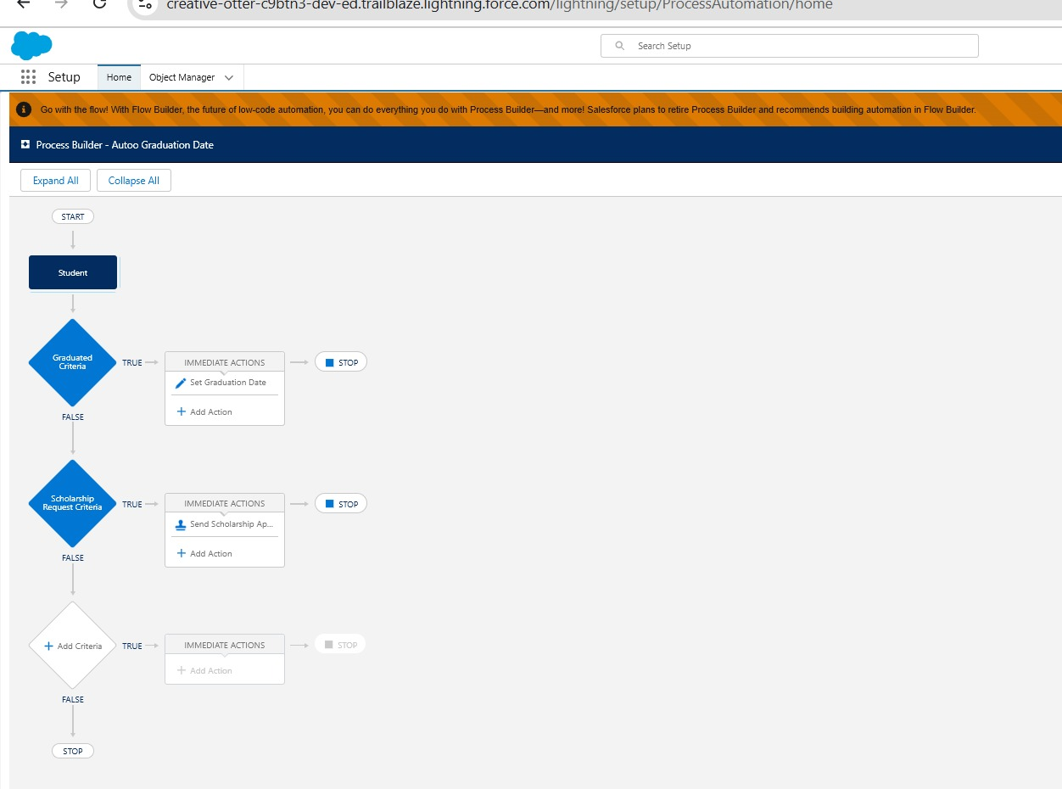

**4. Approval Process**

**Object:** Student__c

* **Process Name:** Scholarship Approval
* **Entry Criteria:** Scholarship_Requested__c = TRUE
* **Steps:**
  1. Initial Submission → Lock record.
  2. Assigned To → Finance Staff Queue.
  3. Final Approval → Unlock record + Update Scholarship_Status__c = "Approved".
  4. Rejection → Update Scholarship_Status__c = "Rejected".

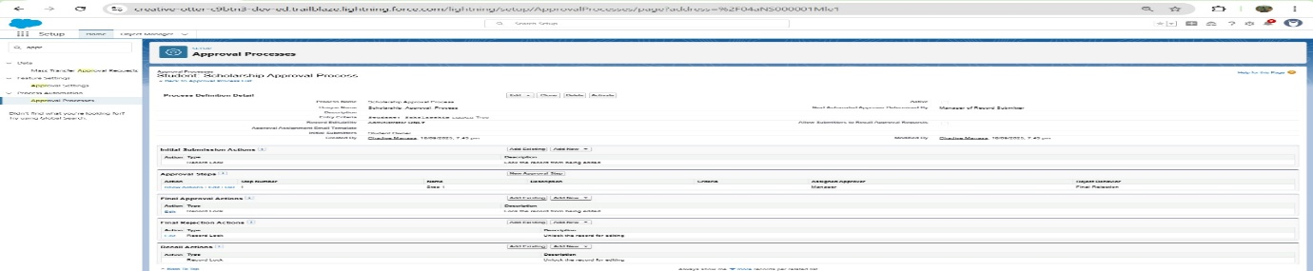

**5. Flow Builder**

**a) Screen Flow: Student Registration**

* **Inputs:** First Name, Last Name, Email, Enrollment Year, Status.
* **Action:** Create Student record in Student__c.

**b) Record-Triggered Flow: Auto Assign Status**

* **When:** A new Student record is created.
* **Condition:** If Enrollment_Year__c = TEXT(YEAR(TODAY()))
* **Action:** Update Status__c = "Enrolled".

**c) Scheduled Flow: Semester Reminder**

* **When:** Every semester start date (Scheduled path).
* **Action:** Send Email Alert to all Student__c records with Status__c = "Enrolled".

**d) Auto-Launched Flow: Calculate Student Age**

* **Formula:** TODAY() - Date_of_Birth__c
* **Action:** Update Age__c field in Student__c.

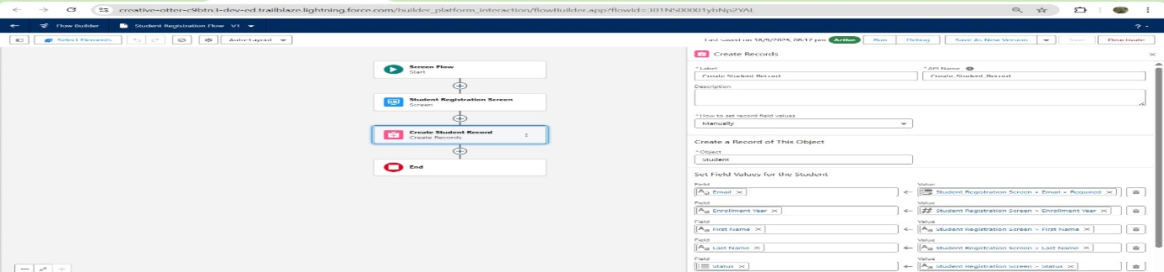

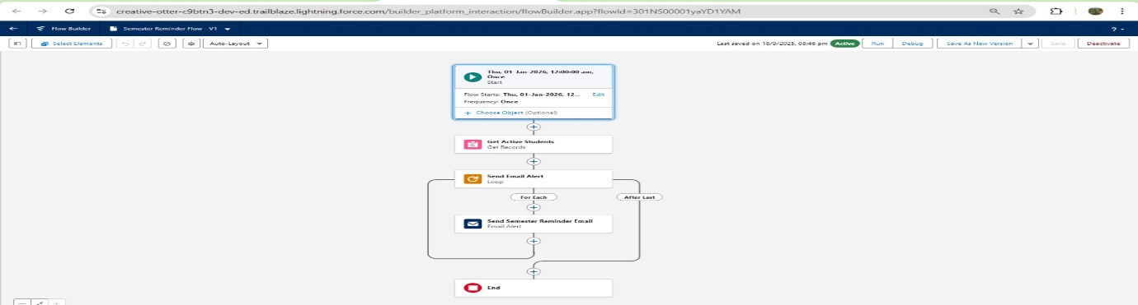

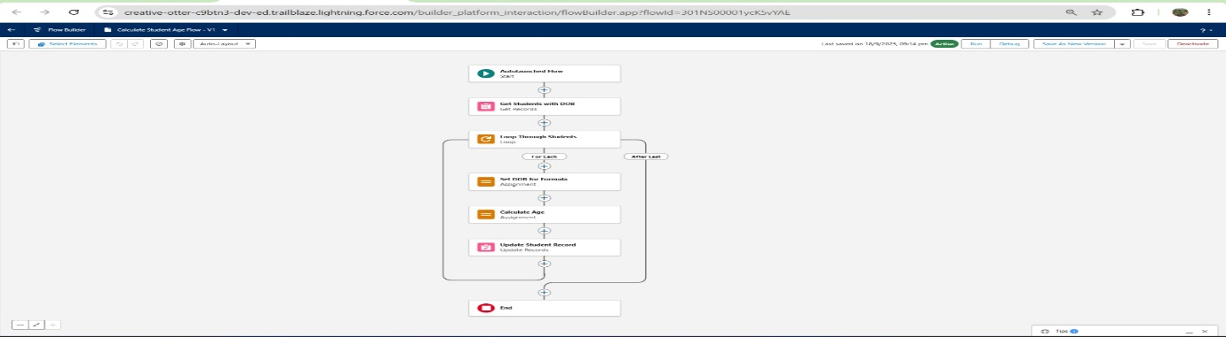

**6. Email Alerts**

**Object:** Student__c

* **Templates Created:**
  1. Welcome Student Email (after registration).
  2. Semester Reminder Email.
  3. Graduation Congratulations Email.

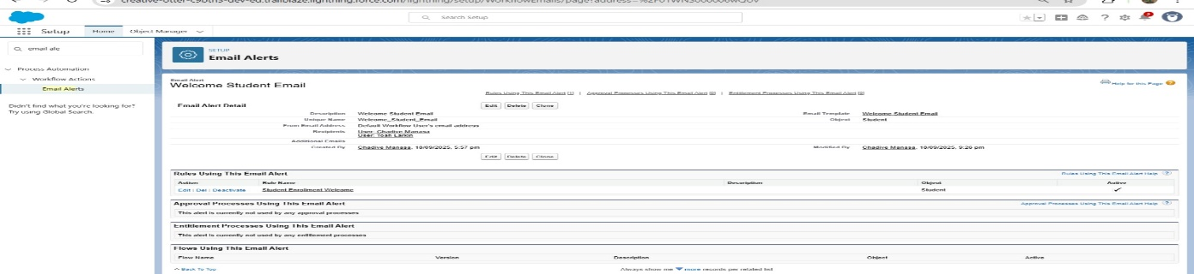

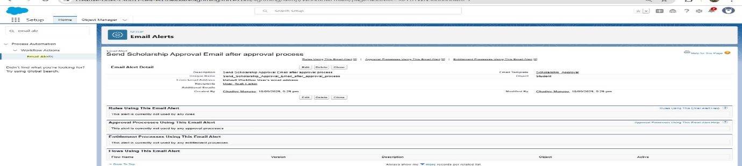

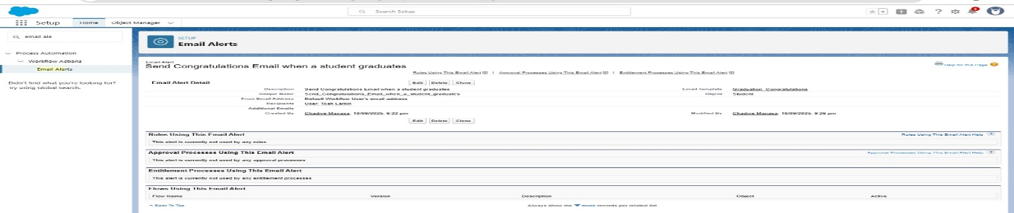

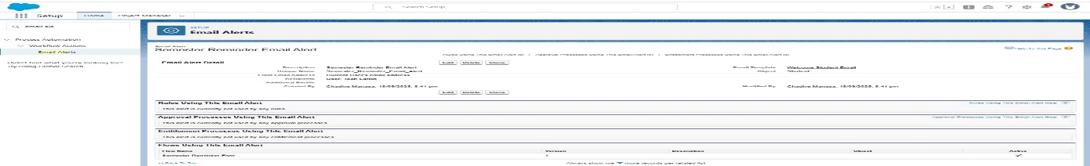

**7. Field Updates**

**Objects & Fields:**

* Student__c.Status__c → "Inactive" (Workflow Rule).
* Student__c.Graduation_Date__c → TODAY() (Process Builder).
* Student__c.Age__c → Formula result (Flow).

**8. Tasks**

**Object:** Student__c

* **Example:** When Scholarship request is approved, create a Task for Finance Staff: "Process Scholarship Payment."

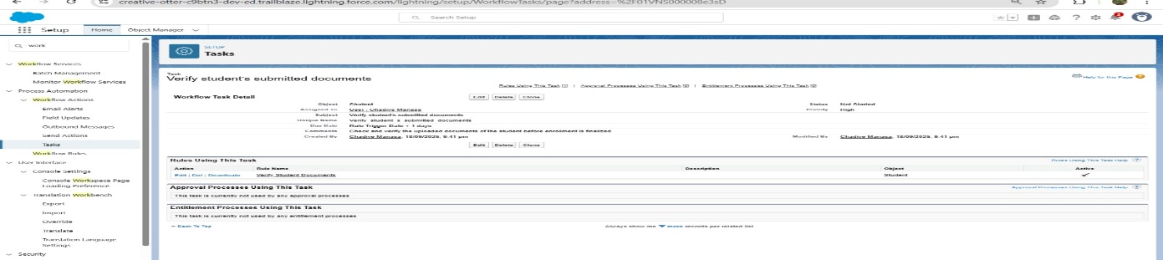

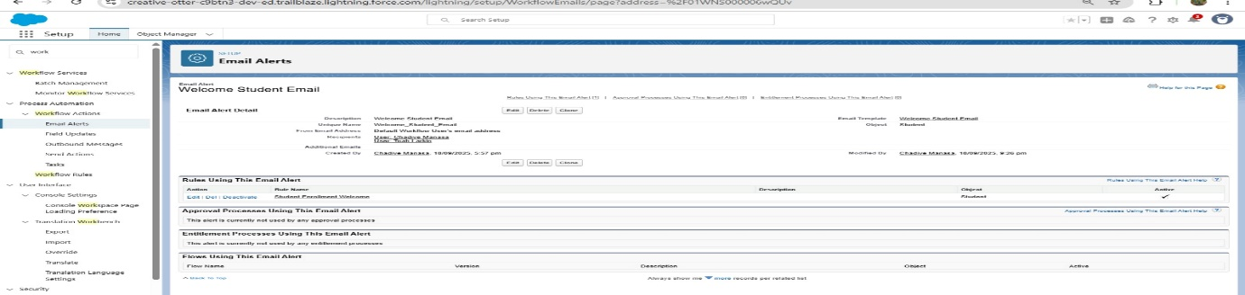

**9. Custom Notifications**

**Object:** Student__c

* **Example:** When a student is marked as “Graduated”, send a **Custom Notification** to the Advisor/Staff to initiate alumni registration.

